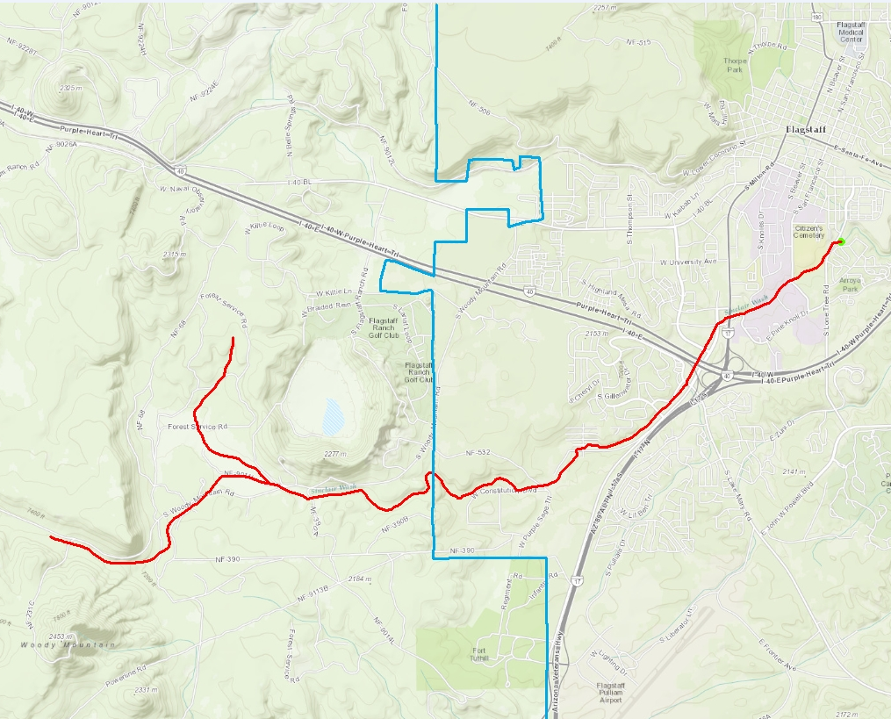
1 Mile
City Limits
Sinclair Wash
Walmart
S Lone Tree Road
Woody Mountain Road
N

